**PROTOCOL**to laboratory exercise

***RC-Sine-Wave-Oscillator***



|  |  |  |
| --- | --- | --- |
| Group / Class | Secretary | Signature |
| 5 / **4BHELS** | HOFSTÄTTER A. |  |
| Exercise- / Delivery date | Employee | Signature |
| 10. Feb. 2015  17. Feb. 2015 | BIEHL S. |  |
| Teacher | Employee | Signature |
| Tillich |  |  |
| Grade | Employee | Signature |
|  |  |  |
| ***RC-Sine-Wave-Oscillator*** | | |
| **Used Devices**   |  |  |  |  |  | | --- | --- | --- | --- | --- | | Nr. | Device | Manufactor | Type | Place Nr. | | 1. | Function Generator | HAMEG | HM8030-6 | - | | 2. | Power Supply | Conrad | PS2403D | - | | 3. | Oscilloscope | Tektronix | TDS 1001B | - |   **Used Programs**   |  |  |  | | --- | --- | --- | | Nr. | Name | Version | | 1. | Altium Designer | 13 | | 2. | Micro-Cap | 11 | | | |

ÜBUNGS-/ABGABE-DATUM

Klasse /Gruppe

NOTE

LEHRER

# Table of Contents

1 Table of Contents 2

2 Tasks 3

3 T-Filter Oscillator (Notch filter) 3

3.1 Calculations 3

3.2 Measurement Circuit 3

3.3 $Vcc$- Dependency 4

3.4 Measurement (Time Domain) 4

3.5 Measurement (FFT) 5

3.6 Total Harmonic Distortion 5

4 Phase-Shifting-Oscillator 6

4.1 Measurement Circuit 6

4.2 $Vcc$- Dependency 6

4.3 Measurement (Time Domain) 6

4.4 Measurement (FFT) 7

4.5 Total Harmonic Distortion 7

# Tasks

Task of this laboratory exercise was to build a several RC-Oscillator Circuit.

1. Calculation
2. Setup and Realisation
3. Measurement of the $V_{cc}$-Dependency
4. Measurement (Time domain and FFT)
5. Calculation of the Total Harmonic Distortion (THD)

The following RC-Oscillator circuits were built.

* T-Filter Oscillator (Notch filter)
* Phase-Shifting-Oscillator

All Oscillators were provided with an unsymmetrical power supply.

$$GND=0 V \\ V_{cc}=15 V$$

The cut off frequency for all following calculations and setups was $f_{G}=300 Hz$.

# T-Filter Oscillator (Notch filter)

## Calculations

Based on the given cut off frequency of 300 Hz the values for R and C were calculated. It was assumed that the capacitor hast a value of 33nF.

$$C=33 nF$$

$$f_{g}=\frac{1}{2*π*R*C}→R=\frac{1}{f_{G}*2*π*C}=\frac{1}{300 Hz*2*π*33 nF}=16 kΩ→R=15 kΩ$$

## Measurement Circuit

|  |  |
| --- | --- |
|  | $$R=15 kΩ$$ $$\frac{R}{2}=7.2 kΩ$$ $$P=100 kΩ$$ $$C=33 nF$$ |

## $V_{cc}$- Dependency

## Measurement (Time Domain)

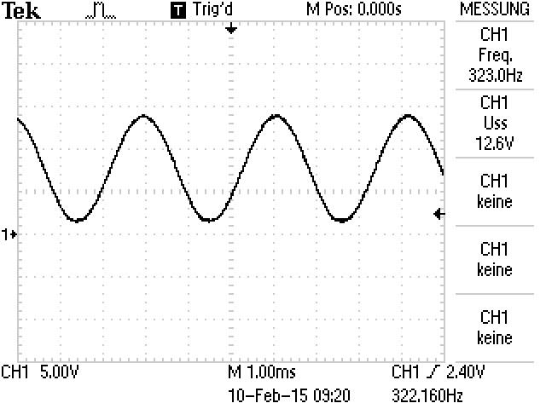

## Measurement (FFT)

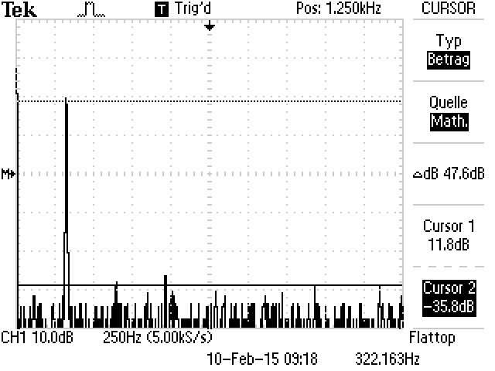

## Total Harmonic Distortion

Based on above measurement (FFT) the difference between the cursors was taken for the following calculations. ($∆Cursor=47,6 dB$)

$$a={10}^{\frac{47,6 dB}{20}}≅240→\frac{1}{240}=4,16*{10}^{-3}→4,16*{10}^{-3}*\sqrt{2}=5,88 {10}^{-3}*100 \%=5,8 \%$$

# Phase-Shifting-Oscillator

## Measurement Circuit

|  |  |
| --- | --- |
|  | $$R=15 kΩ$$ $$\frac{R}{2}=7.2 kΩ$$ $$P=1 MΩ$$ $$C=33 nF$$ |

## $V_{cc}$- Dependency

The oscillator frequency has not changed with a modified supply voltage.

## Measurement (Time Domain)

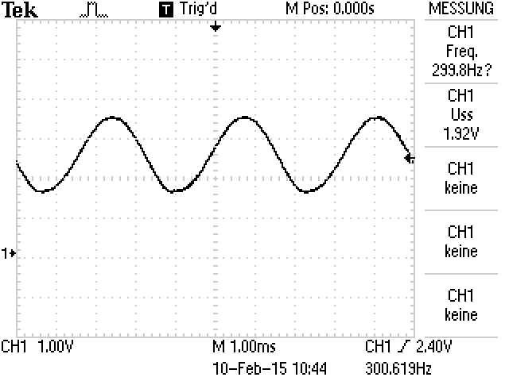

## Measurement (FFT)

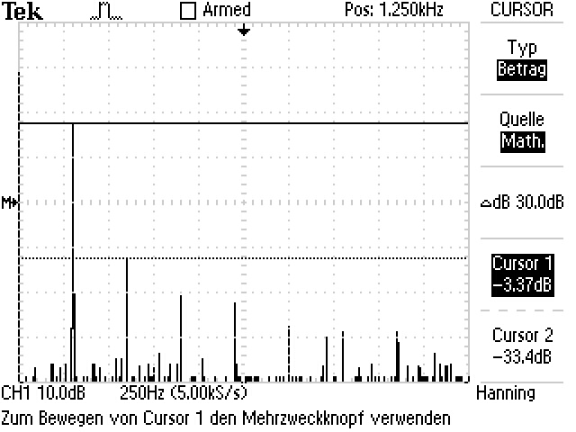

## Total Harmonic Distortion

Based on above measurement (FFT) the difference between the cursors was taken for the following calculations.

Second Harmonic

$$∆Cursor 1=30 dB$$

$$k_{2}=3.2 \%$$

Third Harmonic

$$∆Cursor 2=37 dB$$

$$k_{3}=1.4 \%$$

Fourth Harmonic

$$∆Cursor 3=40 dB$$

$$k_{4}=1 \%$$